1. To generate a token, Run the solution and launch the postman. Copy the url from Browser and paste in POST as shown below. Replace url by api/token.

Click Send and Copy token from result in a notepad file.

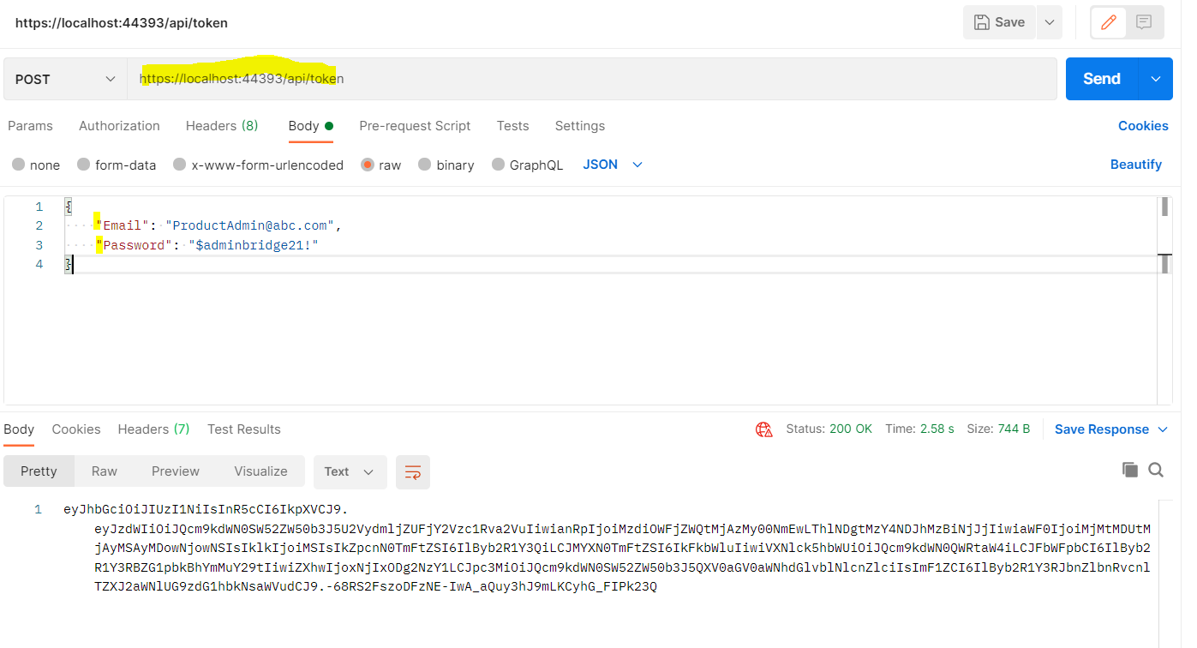

1. Write raw body in JSON format, use Bearer token in Authorization and paste the Token and click send to Push the record in Database using API.

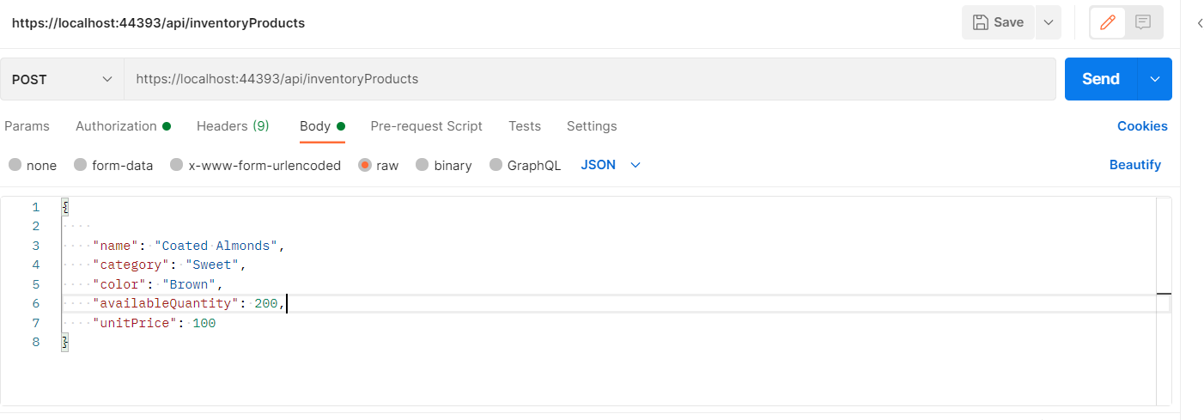

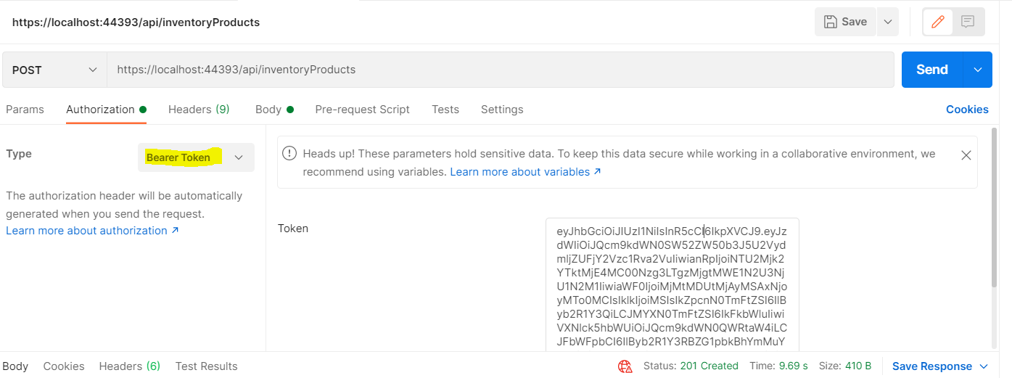

1. Similarly, using Token click, send under GET to see the data.

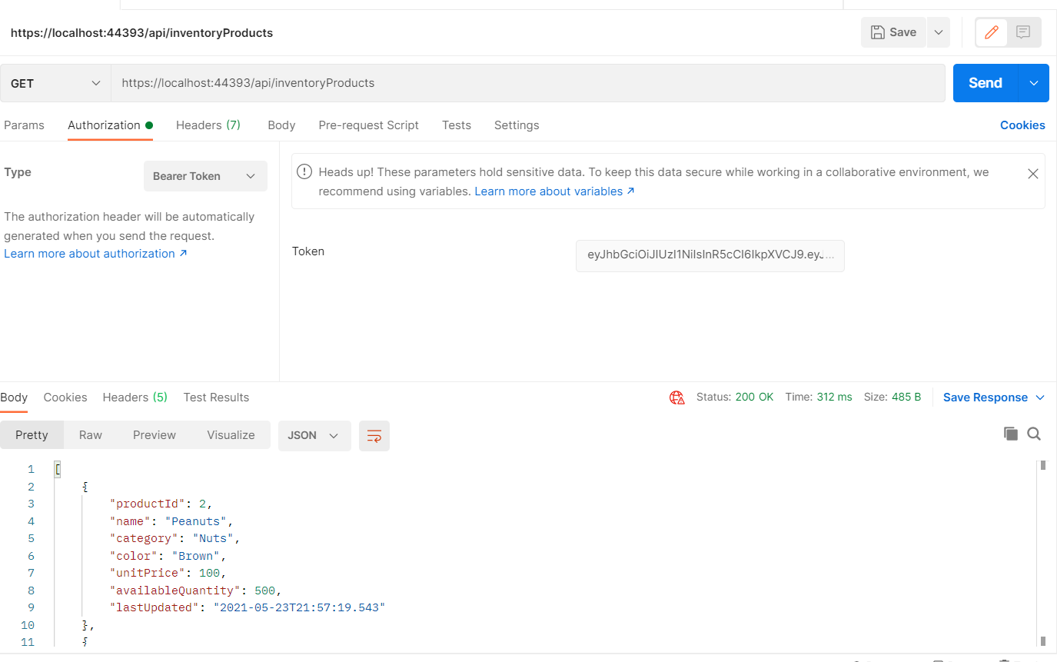

1. Get by ID

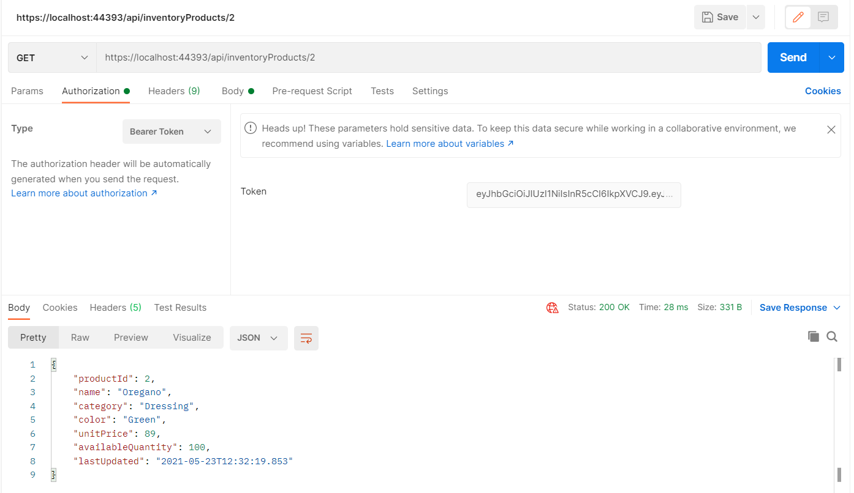

1. To POST

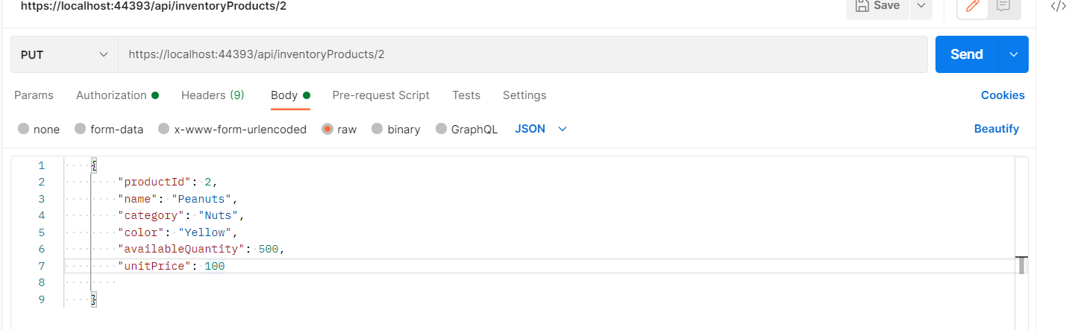

1. DB changes

